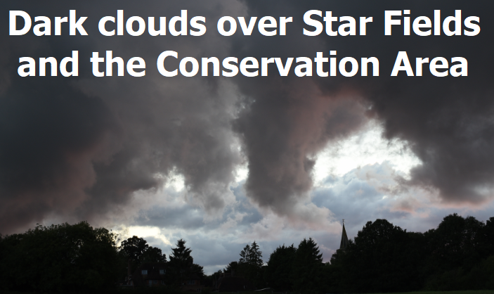
Lingfield Parish Council
Public Meeting

Lingfield Church
Wednesday 5 September 7.30 pm
“The Star Fields &
The Tandridge Local Plan”
Use our guidelines to frame your response to show how you think it is “unsound” in the 4 Tests of Soundness required in your comments:
Download the Guidelines from the Lingfield Parish Council and Neighbourhood Plan websites or
email hello@Lingfield.info for a copy.
www.lingfieldparishcouncil.gov.uk
www.lingfield.info
Please come to the meeting to get more information and help
This is your last chance to submit comments on the Local Plan.
Consultation closes 5pm Monday 10th September
Email them to localplan@tandridge.gov.uk or post to Local Plan, Council Offices, Station Rd East, Oxted, RH8 0BT

